ACE Communications

Call for Architectural Images

Copyright Release Form

Date: 26/01/2020

ACE needs images of your best architectural projects!

Dear colleagues,

ACE would like to invite its Member Organisations to provide images of projects that have received a national architectural award, or images of the best architectural projects in their respective countries.

These images will be used by ACE to illustrate its communications and publications (ACE Info, leaflets, reports, etc.) and to create an on-line exhibition of the best European architectural practices.

For each set of images you send, we kindly invite you to complete the attached copyright release form, in order to allow the ACE to use these images freely.

Images must be sent in JPEG format, in the best quality possible. As such files might be heavy, we recommend using WeTransfer (https://www.wetransfer.com) for sending your files – this website allows you to send up to 2 GB for free.

Images and copyright release form can be sent to julie.deutschmann@ace-cae.eu Please feel free to contact me for any question you may have.

Thank you in advance for your contribution.

Yours sincerely,

Julie Deutschmann
ACE Communications Officer
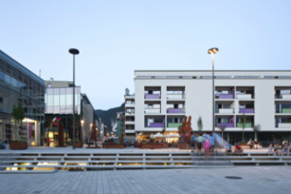
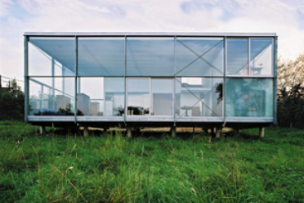
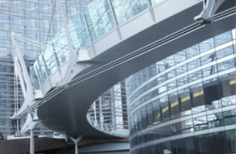
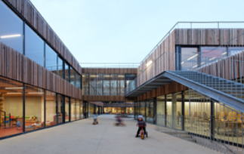
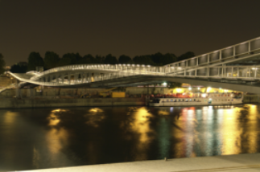

Copyright Release Form

In order to allow the Architects’ Council of Europe to use your images freely, please complete the form below.

I ………………………………………………… (full name), hereby grant permission to the Architects’ Council of Europe freely to use the photographs listed below for the purpose of its communication activities, which can include all types of printed and online publications (eg. newsletters, activity reports, website, social media, PPT presentations, etc.). Architects and photographers will be credited in all publications.

First set of images (name of building, architect and photographer)

- Name of the building:……………………………………………………….……………...
- Name of the architect or the company:………………………………….……………….
- Name of the photographer:………………………………………………………………..
- Function of the building:……………………………………………………………………
- Country and city where the building is located:………………………………………….

Second set of images

- Name of the building:………………………………………………………..……………..
- Name of the architect or the company:…………………………………………………..
- Name of the photographer:………………………………………………………………..
- Function of the building:……………………………………………………………………
- Country and city where the building is located: …………………………………………

Date and signature

